



**CERTIFICATE OF ATTENDANCE**This is to certify that  
Emman  
has attended the ***Global Leadership Summit – Manila South***, on February 23-24, 2018

held at GCF South Metro, located at Versailles Subd., Daang Hari Rd.,

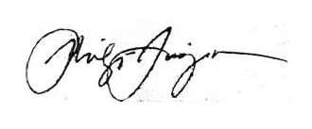Almanza Dos, Las Piñas City, Metro Manila.

**Rev. Bong Baylon Rev. Philip C.Tarroja Dr. Virginia P. Juan**

*GLS Manila South Hub Director GLS Country Convenor, APPEND President/CEO, APPEND*